ENGINEERING STATICS

LIST OF EXPERIMENTS

EXPERIMENT NO 1

TO VERIFY THE PRINCIPLE OF MOMENTS WHICH STATES THAT IF A NUMBER OF COPLANAR FORCES ACTIING ON A BODY S ,KEEP IT IN EQUILIBRIUM AND THEIR MOMENT ARE TAKEN ABOUT ANY POINT IN THEIR PLANE,THE SUM OF THE CLOCKWISE MOMENTS ,IS EQUAL TO SUM OF ANTICLOCKWISE MOMENT.

EXPERIMENT NO 2

I)TO RESOLVE ,BY EXPERIMENT,ANY SUITABLE COMBINATION OF THREE STATIC,COPLANAR FORCES.

II)TO COMPARE THE RESULTS WITH THE GRAPHICAL SOLUTION OBTAINED BY DRAWING A TRIANGLE OF FORCES DIAGRAM

III)TO ILLUSTRATE THE “RESULTANT” OF ANY TWO OF THE FORCES AND TO COMPARE THE MAGNITUDE AND DIRECTION OF ITS EQUAL AND OPPOSITE “EQUILIBRANT” WITH THE EXPERIMENTAL VALUES.

EXPERIMENT NO 3

TO DETERMINE THE REACTION OF A BEAM UNDER VARIOUS LOADINGS

EXPERIMENT NO 4

TO VERIFY THE LAW CONNECTING THE COEFFICIENT OF FRICTION BETWEEN A CORD AND DRUM AND ANGLE OF LAP

EXPERIMENT NO 5

IF A SYSTEM IS IN EQUILIBRIUM UNDER SEVERAL COPLANAR CONCURRENT FORCES;

I)THE FORCES ON THEIR FREE VECTORS MUST FORM A CLOSED POLYGON

II)TO VERIFY THE CONDITION OF

1. ∑ Fx=0 b) ∑ Fy=0

EXPERIMENT NO 6

TO VERIFY THE LAWS OF FRICTION BETWEEN SOLID BODIES AND TO FIND THE COEFFICIENT OF FRICTION BETWEEN WOOL AND VARIOUS OTHER MATERIALS

EXPERIMENT NO 7

TO FIND THE TENSIONS IN VARIOUS PARTS OF A HANGING ROPE LOADED AT VARIOUS POINTS.

EXPERIMENT NO 1

TO VERIFY THE PRINCIPLE OF MOMENTS WHICH STATES THAT IF A NUMBER OF COPLANAR FORCES ACTIING ON A BODY S ,KEEP IT IN EQUILIBRIUM AND THEIR MOMENT ARE TAKEN ABOUT ANY POINT IN THEIR PLANE,THE SUM OF THE CLOCKWISE MOMENTS ,IS EQUAL TO SUM OF ANTICLOCKWISE MOMENT.

APPARATUS

A disc free to rotate about its center,in a vertical plane,pulley,weights

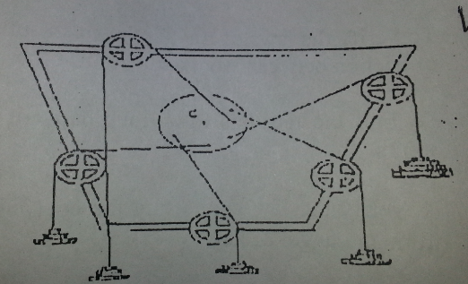

PROCEDURE:

Make sure thst the rotating disc rotates freely about the center C.By points of string point round various pulleys,apply a number of forces P,Q,R,S,T to act on the disc on various points p’,q’,r’,s’,t’ respectively are the perpendicular distances of C from the line of action of forces of the forces P,Q,R,S,T.The moment of these forces about C are Pp’,Qq’,Rr’,Ss’,Tt’.Note whether they are clockwise or anticlockwise.The other forces acting on the disc are its weight anf reaction of the pin at C.Their lines of action pass through C and therefore contribute nothing toward moments.cut of the moments Pp’,Qq’,Rr’,Ss’,Tt’…. And clockwise moments separately and anticlockwise moments separately.Are the two sum s equal ? Enter your results in the following table:

|  |  |  |  |  |  |
| --- | --- | --- | --- | --- | --- |
| CLOCKWISE MOMENT | | | ANTI CLOCKWISE MOMENT | | |
| Force | Distance | Moment | Force | Distance | Moment |
|  |  |  |  |  |  |
|  |  |  |  |  |  |
|  |  |  |  |  |  |

SUM OF clockwise moments = SUM OF Anti clockwise moments

PRECAUTION

1)THE PULLEYS AND THE DISC SHOULD ROTATE FREELY.

EXPERIMENT NO 2

I)TO RESOLVE ,BY EXPERIMENT,ANY SUITABLE COMBINATION OF THREE STATIC,COPLANAR FORCES.

II)TO COMPARE THE RESULTS WITH THE GRAPHICAL SOLUTION OBTAINED BY DRAWING A TRIANGLE OF FORCES DIAGRAM

III)TO ILLUSTRATE THE “RESULTANT” OF ANY TWO OF THE FORCES AND TO COMPARE THE MAGNITUDE AND DIRECTION OF ITS EQUAL AND OPPOSITE “EQUILIBRANT” WITH THE EXPERIMENTAL VALUES.

APPARATUS

A circular steel plate is supported horizontally on three legs attached to a base board.a 360 protractoi is fixed centrally on the plate and a steel peg stands up at the middle.Three pulleys on clamps enable the load hanger cords to un towards a ring dropped over the peg.

EXPERIMENT

Set up three pulley bracket,cords and hangers in any suitable arrangement.let OP coincide with the zero position of the protractor.place load at P and Q .Add a load at R and adjust the and or the disposition of OR until a condition of equilibrium is achieved.it may be helpful to make small changes to make small changes to the loads at P and Q .Success will be apparent when the ring “floats” centrally on the center peg while the apparatus is gently tapped to minimize pulley friction. Record the loads(including the hangers) and their angular direction in table1.

As time permits,make a different arrangement of the cords and loads to obtain further results.if two of the lines of the action are set at right angles to each other this will enable a simple mathematical check to be made on the value of the third force.

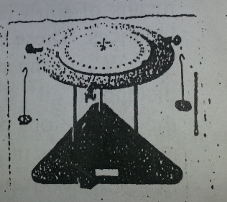

|  |  |  |
| --- | --- | --- |
| Line of action | Direction(“) | Load(N) |
| OP |  |  |
| OQ |  |  |
| OR |  |  |

Results

For each set of results make a graphical presentation as in figure1 and from this construct the triangle of forces as shown in figure2 working clockwise.if the force vectors do not produce a true triangle there is experimental error of direction and or magnitudes.

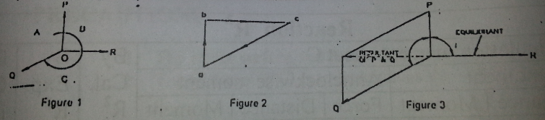

Use the vector diagramshown in figure 3 to illustrate the magnitude and diection of the resultant and equilibrant of the two forces first applied.repeat for other arrangements.

OBSERVATION

While performing the experiment did you see any causes of errors?how sensitive was the system in equilibrium to small changes of load or direction of the cords? Generally did experiment verify the principle of equilibrium?

EXPERIMENT NO 3

TO DETERMINE THE REACTION OF A BEAM UNDER VARIOUS LOADINGS

APPARATUS

Frame fitted with vertical spring balances holding a graduated horizontal beam,stirrups,spirit level weights

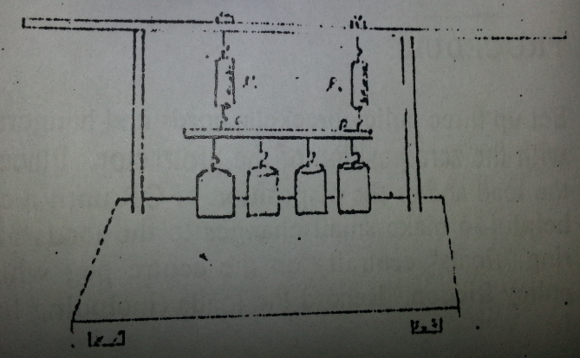

EXPERIMENT

Attach a few stirrups to various points of beam,make it horizontal by means of spirit level and thumbs nuts T1 , T2 and note the readings,in the balances.these ae the zero readings.now attach various load w1,w2,w3,w4 to the stirrups again make beam horizontal.the perpendicular distance d1,d2,d3,d4,…. Of these vertical loads from C can now be read from the graduations on the beam.let the reaction at C AND D be respectively R1 and R2.Then neglecting the weight of stirrups and beam and taking the moment about point C,The sum of clockwise moment must equal to sum of anticlockwise moment.from this we get R2.Further R1+R2=W1+W2+W3+W4+……. And hence R1 can also be found .Compare these values of R1 & R2 with the balance readings and enter the reading in the following table

|  |  |  |  |  |  |  |  |  |  |
| --- | --- | --- | --- | --- | --- | --- | --- | --- | --- |
| **Reaction R^2** | | | | | | | | | |
| **By calculation moment about C** | | | | | | **BY Cal**  **R^2** | **BY Exp**  **R^2** | **BY Cal**  **R^1** | **BY Exp**  **R^1** |
| **Clockwise moment** | | | **Anti Clockwise moment** | | |
| **Force** | **Distance** | **Moment** | **Force** | **Distance** | **Moment** |
|  |  |  |  |  |  |  |  |  |  |
|  |  |  |  |  |  |  |  |  |  |
|  |  |  |  |  |  |  |  |  |  |
|  |  |  |  |  |  |  |  |  |  |
|  |  |  |  |  |  |  |  |  |  |

PRECAUTION

1)The beam should be made horizontal before any reading is taken

2)from the beam readings should be carefully taken down.

EXPERIMENT NO 4

TO VERIFY THE LAW CONNECTING THE COEFFICIENT OF FRICTION BETWEEN A CORD AND DRUM AND ANGLE OF LAP

APPARATUS

A drum,a cord ,pulley arrangements for adjusting the angle of Lap and weights

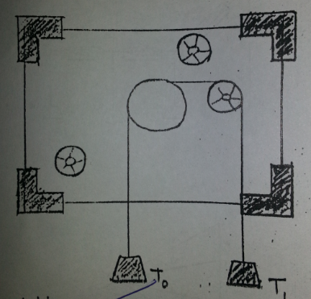

PROCEDURE

First note that the cord can be passed round the drum and various other pulleys so as to give different angle of lap.

Hang a weight T on one side of the cord and pass it round the drum.Attach a weight T at the end of the cord so as to give a slow and steady downward motion to the load T.Keeping T fixed find the value of t coreesponding values of W.enter your results in the following table:

|  |  |  |  |  |  |  |  |
| --- | --- | --- | --- | --- | --- | --- | --- |
|  |  |  |  |  |  |  |  |
| T |  |  |  |  |  |  |  |
| T/T |  |  |  |  |  |  |  |
| Log(T/T) |  |  |  |  |  |  |  |
| (1/) log(T/T) |  |  |  |  |  |  |  |
| Coefficient of friction | | | | | | | |
| Mean value of(1/ Ө)log(T/T) | |  | | Slope of graph | |  | |

GRAPH

Plot your observation taking Ө(radians) along x-axis and log(T/T) along the y-axis .Do the points appear to be on a straight line passing through the origin?Find the slope of the straight line.This gives the coefficient of friction between the cord and the drum.compare it with the mean value of (1/ Ө)log(T/T) calculated from the table.write the formula you have verified.

PRECAUTIONS:

1)The Motion of the cord should be slow and steady

2)the pulley should rotate freely.

EXPERIMENT NO 5

IF A SYSTEM IS IN EQUILIBRIUM UNDER SEVERAL COPLANAR CONCURRENT FORCES;

I)THE FORCES ON THEIR FREE VECTORS MUST FORM A CLOSED POLYGON

II)TO VERIFY THE CONDITION OF

1. ∑ Fx=0 b) ∑ Fy=0

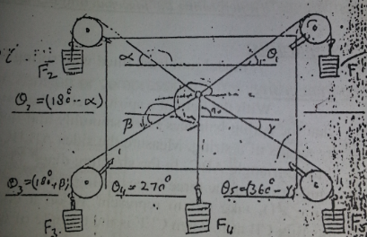

APPARATUS

Pulleys,board in vertical plane,steel rule,PROTRACTOR ,weight with string hanger

PROCEDURE

Apply a no of forces f1,f2,f3,f4,f5 on the strings passing over the pulleys.line of action of all the forces are acting at a point which are shown by string attached to a small ring.note the magnitude and directional of forces.tabulate these forces and angle.draw vector of forces by their direction on any scale using head to tail rule.

Their free vector must form a closed polygon by joining the end point points of the vector of last forces with the first point of ist force.

Secondly resolve the forces on x-axis and y-axis

IF ∑ Fx=0 ∑ Fy=0 THEN

The system will be in equilibrium

PRECAUTIONS:

1)pulley should rotate freely

|  |  |  |  |  |  |
| --- | --- | --- | --- | --- | --- |
| Sr# | Forces | Angles | Summation FX | Summation FY | Remarks |
|  |  |  |  |  |  |
|  |  |  |  |  |  |
|  |  |  |  |  |  |
|  |  |  |  |  |  |
|  |  |  |  |  |  |
|  |  | Total |  |  |  |

EXPERIMENT NO 6

TO VERIFY THE LAWS OF FRICTION BETWEEN SOLID BODIES AND TO FIND THE COEFFICIENT OF FRICTION BETWEEN WOOL AND VARIOUS OTHER MATERIALS

APPARATUS

Base ,spirit level ,slides of various materials and weights

PROCEDURE

Take a slider with wooden base ,weight it and place it on the sliding base made horizontal by mean of spirit level.

With a string attached to the slider ,apply to it a small horizontal force

Go on inceasing this until sliding just begin to move

Now add a load to the slider and fing the horizontal force which is just enough to move it

Repeat the process for various loading.

If “W” is total weight of the slider on the load in it and “F” is corresponding horizontal forcejust enough to maintain a slow and steady motion.

GRAPH:

Draw a graph showing “W” along X-axis and “F” along Y-axis.does it appear to be straight line passing through the origin “O”.

Find its slope.this gives the coefficient of friction between wood and base of the slider.

Compare it with average value of F/W obtained from your readings.

Next take your readings using sliders of base of several materials.

Draw their graphs and find respective coefficient of frictions.

|  |  |  |  |  |  |
| --- | --- | --- | --- | --- | --- |
| Copper upon wood | | | Wood upon wood | | |
| F(g) | W(g) | U=F/W | F(g) | W(g) | U=F/W |
|  |  |  |  |  |  |
|  |  |  |  |  |  |
|  |  |  |  |  |  |
|  |  |  |  |  |  |
| Average coefficient of firiction= | | | Average coefficient of firiction= | | |

|  |  |  |  |  |  |
| --- | --- | --- | --- | --- | --- |
| Brass upon wood | | | Plastic upon wood | | |
| F(g) | W(g) | U=F/W | F(g) | W(g) | U=F/W |
|  |  |  |  |  |  |
|  |  |  |  |  |  |
|  |  |  |  |  |  |
|  |  |  |  |  |  |
| Average coefficient of firiction= | | | Average coefficient of firiction= | | |

PRECAUTION

1)The slider surface and force “F” should be horizontal.

2)the value of “W” is to be taken as the sum of weight of slider and the load in it.

COMMENTS

1)The motion of the slider should be slow and steady

2)make the slider base horizontal by means of a spirit level.

EXPERIMENT NO 7

TO FIND THE TENSIONS IN VARIOUS PARTS OF A HANGING ROPE LOADED AT VARIOUS POINTS.

APPARATUS

A hanging rope fitted with spring balances and weights

PROCEDURE

First note the zero readings of the spring balances in the various parts of the rope A,B,C,D,E.Then apply loads W1,W2,W3 respectively at points B,C & D.Against a vertical board draw the vertical through by mean of plumb line and find the Ө1 between this vertical and AB.similarly find the angle Ө2 betwe the en ED andvertical at E.Now on a convenient scale,take a line FGHI to represent the total load W1,W2,W3 such that FG represent W1,GH represent W2,HI represent W3.Draw IJ & FJ so that the angle IFJ=Ө1 & angle FIJ=Ө2 join GJ & HJ.

Satisfy yourself that FIJ is the triangle of forces for the whole rope ABCDE,also that FGJ is the triangle Of forces acting at H & GHJ is the triangle of forces acting at C.Hence the tension in the parts AB,BC,CD,DE are given espectively by magnitude of FJ,GJ,HJ,IJ.Compare these with the spring balances readings and noted the results in the table.

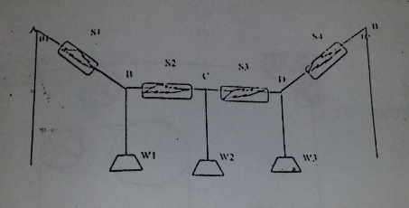

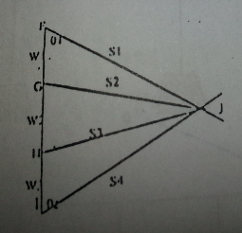

Repeat the experiment three or four times.

|  |  |  |  |  |  |  |  |  |  |  |  |  |
| --- | --- | --- | --- | --- | --- | --- | --- | --- | --- | --- | --- | --- |
| Load | | | Force in AB S1 | | Force in BC  S2 | | Force in CD S3 | | Force in DI  S4 | | Angle | |
| W1 | W2 | W3 | By  Diag | By  EXP | By  Diag | By  EXP | By  Diag | By  EXP | By  Diag | By  EXP | 01 | 02 |
|  |  |  |  |  |  |  |  |  |  |  |  |  |

PRECAUTIONS

1)Note the zeo reading of the spring balances.

2)see that the weights do not touch the ground.

ENGINEERING DYNAMICS

LIST OF EXPERIMENTS

1)TO DETERMINE THE MECHANICAL ADVANTAGE OF AN INCLINED PLANE BY DRAWING A GRAPH BETWEEN W & P.

2)TO COMPAE THE EFFICIENCIES OF A SQUARE THREAD AND V THREAD

3)TO DETERMINE THE MOMENT OF INERTIA OF A FLYWHEEL BY A FALLING WEIGHTS METHOD

4)TO FIND THE VELOCITY RATIO ,MECHANICAL ADVANTAGE,LOAD LOST IN FRICTION AND EFFICIENCY OF WESTON DIFFERENTIAL PULLEY.

5)TO VERIFY THE RELATIONSHIP BETWEEN ANGULAR AND LINEAR VELOCITY.

6) a)TO RESOLVE,BY EXPERIMENT,THE COMBINATION OF THE THREE STATIC COPLANAR FORCES, WHICH EXIST IN LOADED DERRICK CRANE

b)TO COMPARE EXPERIMENTAL RESULTS WITH GRAPHICAL SOLUTION OBTAINED BY CONSTRUCTING TRIANGLE OF FORCE DIAGRAM

c)TO INVESTIGATE THE EFFECT ON THE FORCES BY ALTERING THE GEOMETRIC SHAPE OF CONFIGURATION.

EXPERIMENT # 1

TO DETERMINE THE MECHANICAL ADVANTAGE OF AN INCLINED PLANE BY DRAWING A GRAPH BETWEEN W & P

APPARATUS

smooth inclined plane with frictionless pulley,trolley ,scale pan,weight,spring balance,meter Rod

and a plumb line.

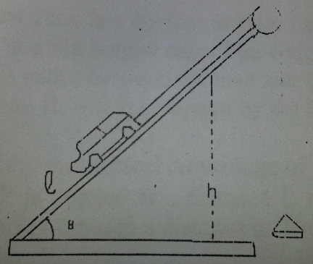

PROCEDURE

Find the weight of the trolley or roller and the scale pan with a spring balance.clean the the surface of the inclined plane and adjust it at an angle of 30 to 45.connect the trolley and scale pan by a thread ,which pass over pulley.the trolley is placed in the middle of the inclined plane and scale pan hangs freely.Adjust the weight in the scale pan till on gently tapping the inclined surface.the trolley just move up and then just move down.the mean of the weights in the scale pan when the trolley moves up & move down plus the weight of the scale pan gives P and the weight of the trolley plus weight in it gives W.

Repeat the experiment several time by placing different weight in the trolley or by using roller of different weights,but keeping the same angle of inclination .thus we will have several values of P corresponding to same number of value of W.Taking W along X-axis and P along Y-axis.Plot graph between them by selecting a suitable scale .Take a point on the graph.Measure its distance from x-axis and y-axis.the distance from x-axis give value of P and from y-axis,the corresponding value of W.Then W/P gives mechanical advantage.take a point on the lower edge of inclined surface and measure its vertical distance ‘h’from upper surface of horizontal plane and also distance ‘I’ from the hinges.then I.MA=L/h.For smooth plane

A.M.A=I.M.A

PRECAUTION

1)The pulley and trolley should be frictionless.

2)the plane should be gently tapped

3)the string should be parallel to the inclined plane.

OBSERVATION & CALCULATION

ZERO READING OF THE SPRING BALANCE = gms Wt

Wt of the trolley(W) = gms Wt

Wt of the scale pan(p)= gms Wt

Distance along the lower edge from the hinges(I)= cms

Vertical distance measured with plumb line and meter rod = cms

Angle of inclination of the plane =

(Ө=SIN(h/I)

|  |  |  |  |  |
| --- | --- | --- | --- | --- |
| SR No | W=w+wts in the trolley | Wts in the pan when the trolly just moves up down mean P1 P2  (P1+P2)/2 | Power P=  (P1+P2)/p+p | Annual mech.Advantage  W/P |
| 1 |  |  |  |  |
| 2 |  |  |  |  |
| 3 |  |  |  |  |
| 4 |  |  |  |  |
| 5 |  |  |  |  |
| 6 |  |  |  |  |

1)By calculation ,mean W/P=

2)Value of p from the graph=

3) Value of w from the graph=

4)hence actual mechanical advantage(W/P)=

5)Ideal Mechanical Advantage(I/h)=

EXPERIMENT # 2

TO COMPAE THE EFFICIENCIES OF A SQUARE THREAD AND V THREAD

APPARATUS

Screw having square thread as well as V THREAD AND WEIGHTS

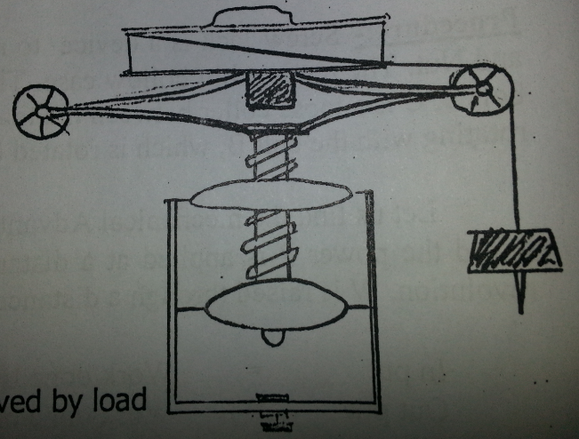

Procedure

First work the screw on the square thread.for one complete turn of a table,the effort works through the circumference of the table and load rises through the pitch of square thread.measure these and calculate velocity ratio,V

V=Distance moved by effort/distance moved by load

Now find the effort P that is just sufficient to raise the load W applied to the screw .Do this for W=0,4,8,12,….. LBS.For each reading calculate the efficiency given by the expression:W/Pv

Next work the screw on the v-thread and calculate the corresponding velocity ratio.Applying the same set of loads,W=0,4,8,12,…..LBS.Find the respective corresponding effort and calculate the efficiency at each reading.Enter your result in following table:

|  |  |  |  |  |
| --- | --- | --- | --- | --- |
| Load  W | Effort P | | % Efficiency(w/pv)*100 | |
| Square thread | V-thread | Square thread | V-thread |
| 0 |  |  |  |  |
| 4 |  |  |  |  |
| 8 |  |  |  |  |
| 12 |  |  |  |  |

GRAPH

Now on the same graph paper ,taking load along the x-axis and efficiency along y-axis,plot the graphs between load and efficiency for each reading of the two type of thread.

PRECAUTIONS

1)Determine the pitch of the screw carefully

2)take care that the effort is applied in such a way that the load is raised and not lowered

3)that value of the effort is to be considered that is just enough to raise the load W

EXPERIMENT#3

TO DETERMINE THE MOMENT OF INERTIA OF A FLYWHEEL BY A FALLING WEIGHTS METHOD

APPARATUS

Flywheel ,cotton thread,meter rod,heavy weight,set square,stop watch,caliper

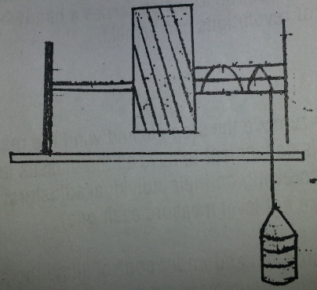

PROCEDURE

Measure the diameter of the axle AB at various three places.Find out mass ‘m’ by a spring balance.take a piece of thread of length slightly less than the height of the flywheel from the ground.Make a small at one end of the thread and slip it over the peg p.connect the mass ‘m’ to the other end of the thread wound the thread around the axle of the flywheel uniformly and closely.count the number of thread turns which flywheel takes in winding or unwinding the string.

h=∏dn

make a mark over the flywheel and allow the weight suspended to fall.as the thread length is less than the height of the flywheel from the ground.loop of the thread just step out from the peg.there by from the axle as sson as the weight is detached from the flywheel .start and measure the time t,taken by flywheel to come to rest .also count the number of rotation completed by the flywheel during the time t,calculate the moment of inertia of flywheel from relation

I=mgh2/8∏N(N+n)

|  |  |  |  |  |  |  |  |
| --- | --- | --- | --- | --- | --- | --- | --- |
| S.r# | Suspended mass (m) | Turns  (n) | Height  (h) | Reaction of fly wheel(N) | Velocity  (ω) | Time taken  (t) | M  O  I |
|  |  |  |  |  |  |  |  |
|  |  |  |  |  |  |  |  |
|  |  |  |  |  |  |  |  |

EXPERIMENT # 4

TO FIND THE VELOCITY RATIO ,MECHANICAL ADVANTAGE,LOAD LOST IN FRICTION AND EFFICIENCY OF WESTON DIFFERENTIAL PULLEY.

APPARATUS

Weston differential pulley,block and weight

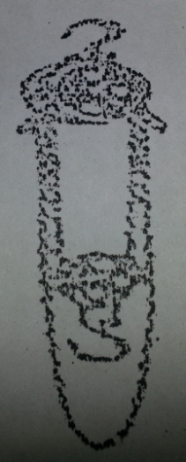

PROCEDURE

If the effort p moves through one complete circumference of the larger pulley the net shortening of chain is equal to difference of the circumference of larger and smaller pulley and as two chain hold the hold w,the distance through which later rises is equal to half the difference between circumference.hence the velocity ratio “V” is given by

V=Distance moved by effort = Circumference of larger pulley

Distance moved by load ½ (difference b/w circumferences)

Calculate first of all this now find the effort”P” Which is just sufficient to raise load “w”,do this for different loads w =0,7,14,21,28,35,….lbs

Mechanical Advantage is given by the experiment w/p and the efficiency by w/pv.calculate these for each reading.if the machine was ideal the load L Lifted by it would satisfy the relation

Px distance moved by effort=Lxdistance moved by load

Or L=Pv

Instead we are able to lift only a load w,hence L-W(i.e pv-w)is called the load lost in friction .calculate also it for each reading and enter the results in the table.Finally,on the same graph paper and with the same axis for load w,draw the graph between load and effort,efficiency and load &load lost in friction and load.take w along x-axis and all other quantities along y-axis

Velocity ratio=v=

|  |  |  |  |  |
| --- | --- | --- | --- | --- |
| Load w | Effort “p” | Mechanical advantage w/p | Efficiency  w/pv | Load lost in friction pv-w |
|  |  |  |  |  |

PRECAUTIONS

I)take care that effort is applied in such a way that load is raised and not lowered

Ii)that value of effort p is to be considered which is just enough to raise load w

Iii)copy the readings and take graphs.

Experiment # 5

To verify the relationship between angular and linear velocity.

Apparatus

It consist of an axle mounted in bearings.the axle has three different diameter around which a light cord is wrapped and free end carries a small mass.the axle also carries a handwheel at one end which has a stop pin so that an exect number of revolutions can be held.

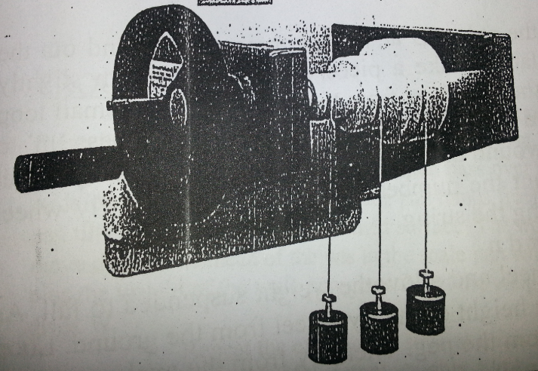

Procedure

If necessary remove the stop pin and wind the masses up so that all are near the axle.then replace the stop pin.it is convenient to have all masses level to start,but not essential.the masses can be adjusted by screwing on their individual adjuster.measure the height of a mass above the floor(if masses are not level then measure each one).

Remove the stop pin and under control allow the shaft to rotate a number of times,say five.then replace the stop pin.again measure the respective axle diameters and note your data in a suitable table.

Results

Fill in the table below your experimental data and compute the remaining values.

|  |  |  |  |
| --- | --- | --- | --- |
| AXLE DIAMETER | 30 mm | 50 mm | 70 mm |
| Initial height(h1) | 1.425m | 1.426m | 1.424m |
| final height(h2) | 0.925m | 0.640m | 0.326m |
| S=h1-h2 | 0.473m | 0.786m | 1.098m |
| s/d | 15.8 | 15.7 | 15.7 |

W=2s/rt

As the axle is rigid, w and t are same for all three diameters during the motion.hence we may write

s1/r1=s2/r2=s3/r3

EXPERIMENT# 6

a)TO RESOLVE,BY EXPERIMENT,THE COMBINATION OF THE THREE STATIC COPLANAR FORCES, WHICH EXIST IN LOADED DERRICK CRANE

b)TO COMPARE EXPERIMENTAL RESULTS WITH GRAPHICAL SOLUTION OBTAINED BY CONSTRUCTING TRIANGLE OF FORCE DIAGRAM

c)TO INVESTIGATE THE EFFECT ON THE FORCES BY ALTERING THE GEOMETRIC SHAPE OF CONFIGURATION..

Procedure

SETUP THE APPARATUS AS DESCRIBED ABOVE.ADJUST THE COLLAR AS REQUIRED AND ENSURE THAT THE FORK END OF THE JIB IS SCREWED WELL INTO THE SLEEVE TO ALLOW FOR ADJUSTMENT AFTER LOADING.SELECT SUITABLE DIMENSION FOR THE JIB,TIE THE HEIGHT OF THE COLLAR AND CAREFULLY NOTE THE DIMENSIONS a,b,c AND d shown in the sketch below.the hanger should not be fitted at this stage.

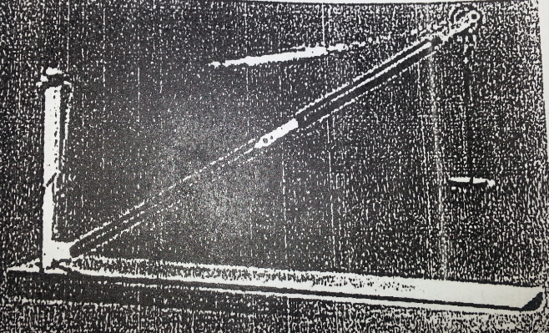

Note the initial readings of the tie and jib balances.suspend a suitable load(including the mass of the load hanger)from the hook.adjust the length of tie by altering the cord and adjust the length of jib by revolving the jib sleeve until the original dimensions of the configuration are re-established.now note the final readings of jib and tie balances.repeat for different loads.

Change the shape of the configuration and repeat the above experiments.

RESULTS

Tabulate the results as follows

|  |  |  |  |  |  |  |  |  |  |  |
| --- | --- | --- | --- | --- | --- | --- | --- | --- | --- | --- |
| Dimensions | | | | Applied Load | Jin Force(J) | | | Tie Force(T) | | |
| a | b | c | d | Initial | Final | Net | Initial | Final | Net |
|  |  |  |  |  |  |  |  |  |  |  |
|  |  |  |  |  |  |  |  |  |  |  |
|  |  |  |  |  |  |  |  |  |  |  |
|  |  |  |  |  |  |  |  |  |  |  |
|  |  | Total |  |  |  |  |  |  |  |  |